**Advanced C Lab DA 3**

**Name:**Vinayak Swaroop Bhatnagar

**Regno:**20BCI0070

Q1. VIT has various clubs and chapters to cater to the intellectual needs of the students. Separate files are maintained for each club. The following information about the students are maintained in every club file ( Name, Reg No, Gender, CGPA, number of activities organized, number of activities participated, position held in the club (President/Member/Treasurer) and level of performance rated by the coordinator (1/2/3). Write a C program to do the following:

1. Create two files one for each club
2. Add a new student to both the clubs
3. Identify and display the names and registration numbers of the students who are eligible for special consideration for award base on the following criteria:
   1. CGPA>9
   2. Activities organized >4
   3. Performance level 1
4. Display the names of the Top 2 boys and girls who satisfy the aforementioned criteria.
5. Modify the position of the highest CGPA student to President and second highest student to Treasurer.

Note: Ensure that the names are not duplicated as the same student can be a member of more than one club.

Source Code:

Click here

Also added at the end

1. File Creation:

Files are created as soon as the program is run

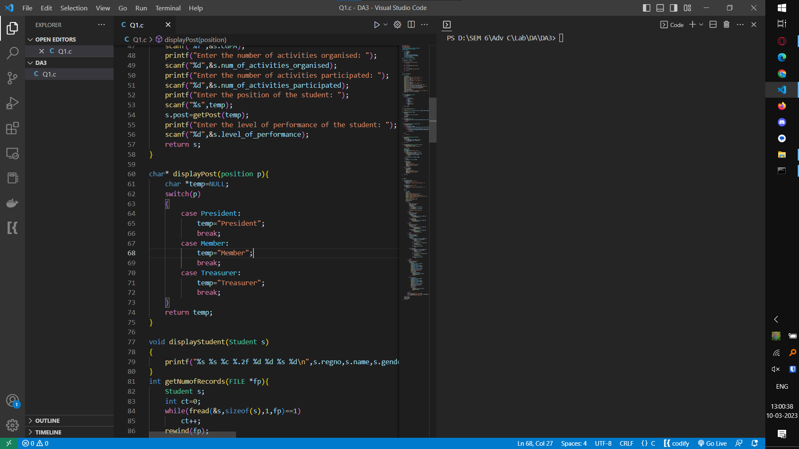

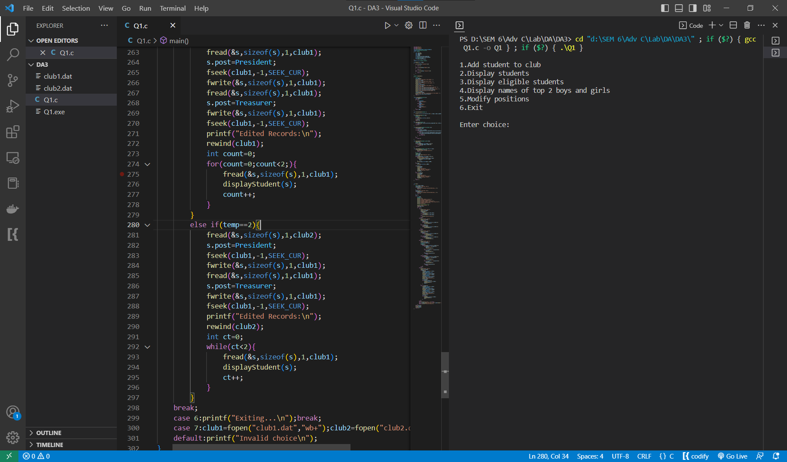

1. Inserting Students

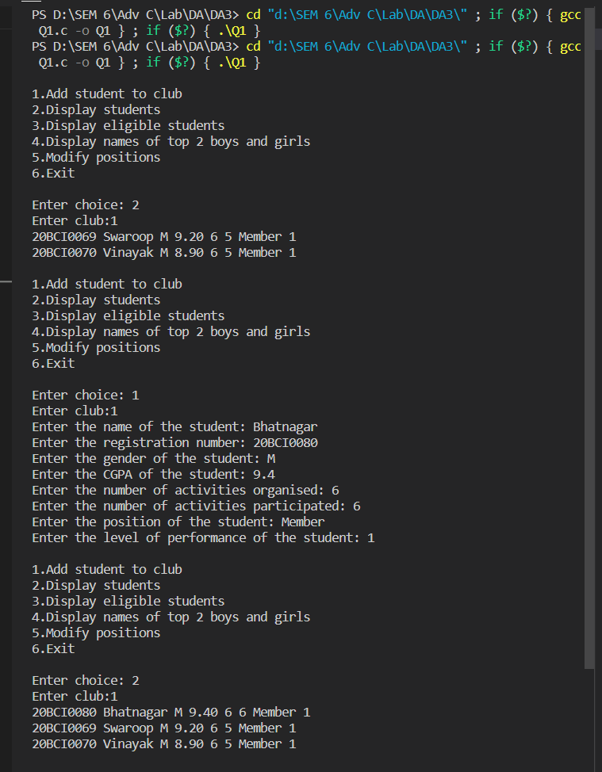

1. Display Eligible Students

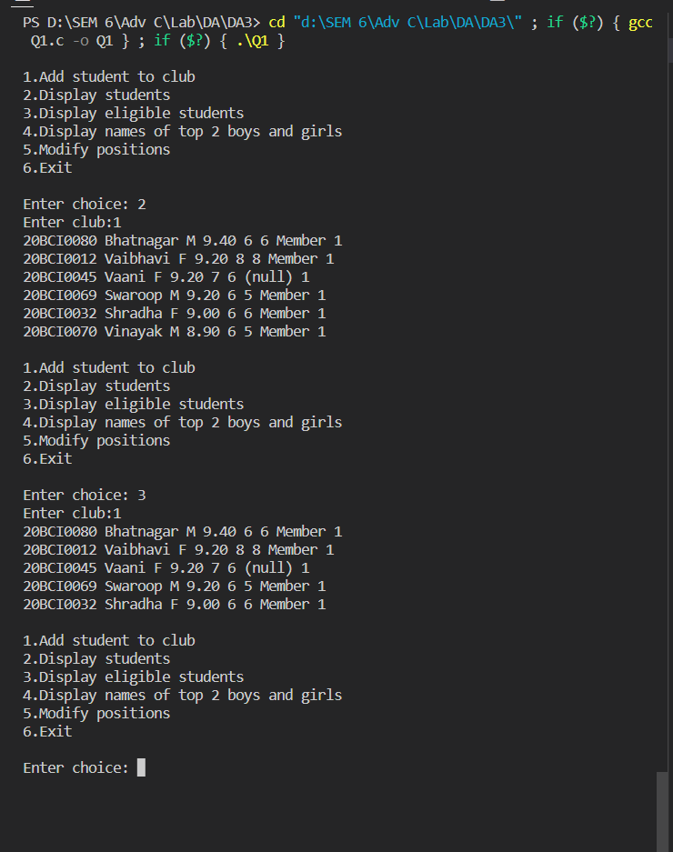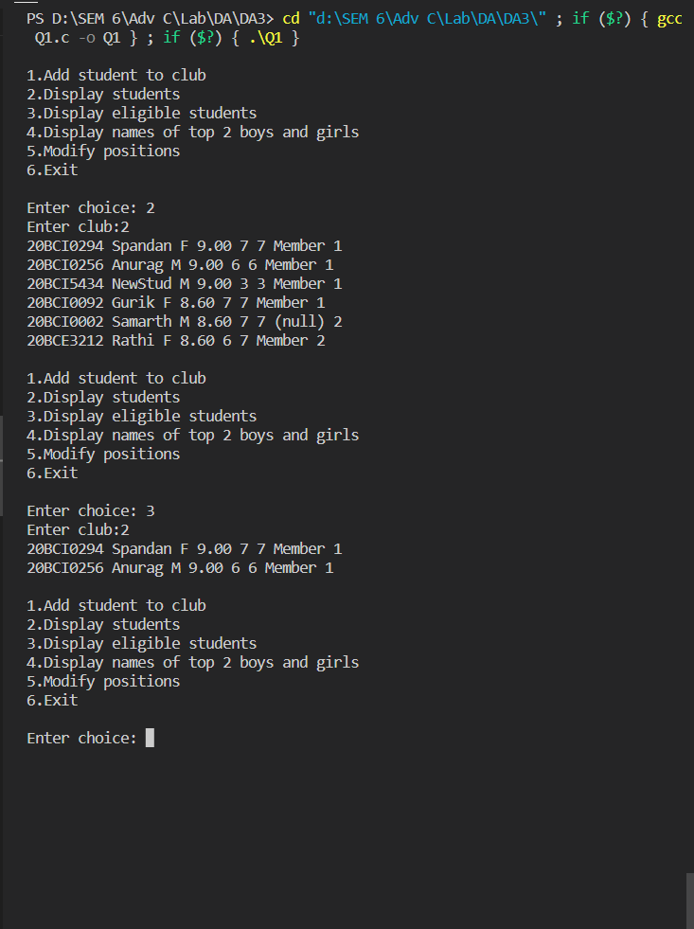

1. Names of top 2 boys and girls of each club

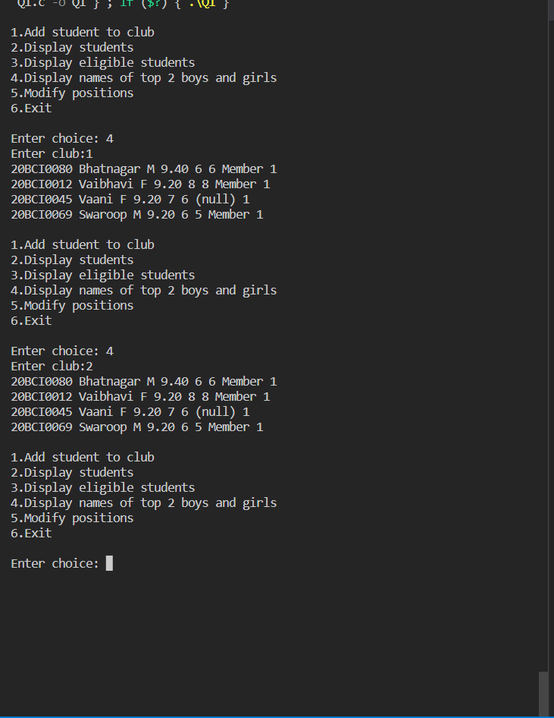

1. Promote postiions

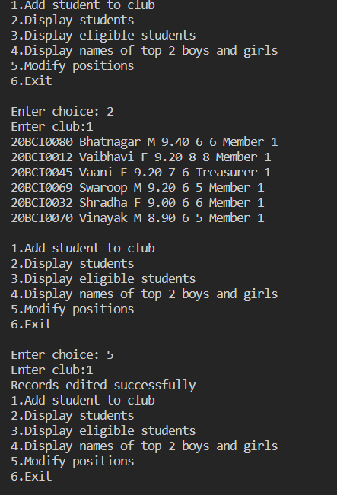

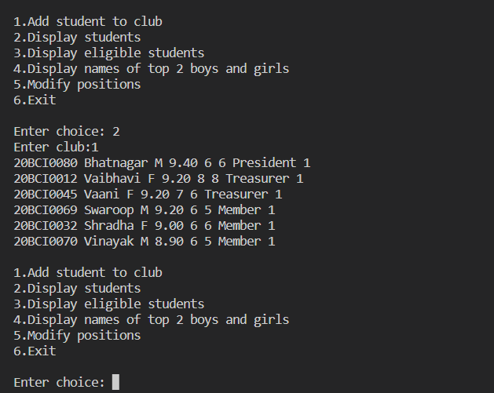

Q2. Create a file to maintain student details such as name, reg.no, programme, school, CGPA and rank. Write a C program that will update the rank of the students based on the CGPA obtained. Let the ranks be initialized to 0. Also, find the number and names of the students who have scored <4 CGPA and enter their details into another file (monitor file).

Source Code:

Click here

Also added at the end

1. Insertion

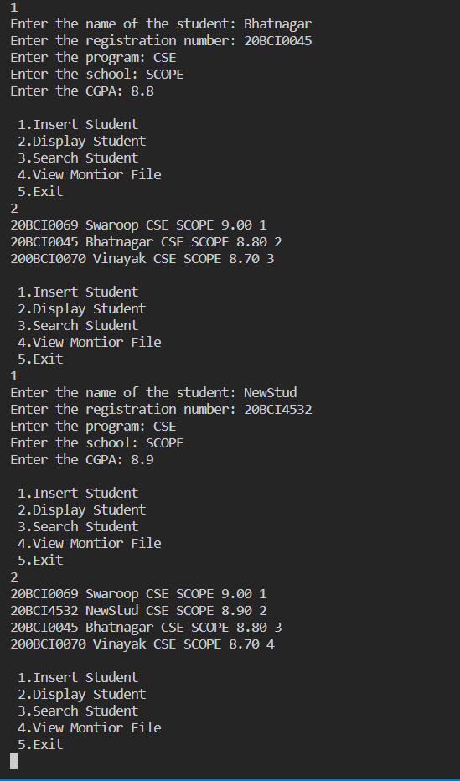

1. View Monitor File

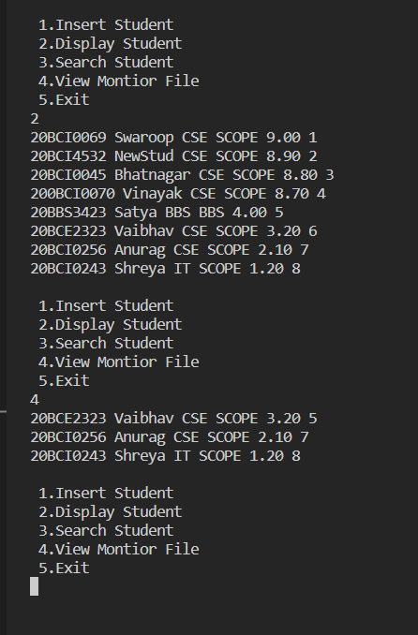

1. Searching

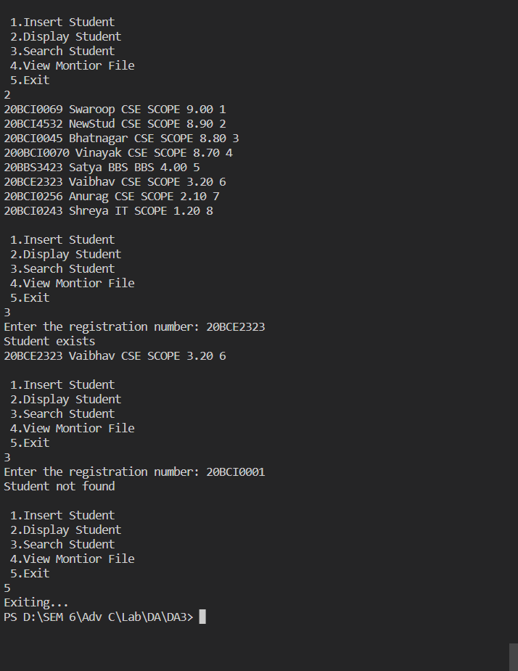

Q1. Source Code:

#include<stdio.h>

#include<string.h>

#include<stdlib.h>

enum position{President,Treasurer,Member};

typedef enum position position;

struct Student

{

    char name[20];

    char regno[20];

    char gender;

    float CGPA;

    int num_of_activities_organised;

    int num_of_activities_participated;

    enum position post;

    int level_of_performance;

};

typedef struct Student Student;

int getPost(char *temp)

{

    if(strcmp(temp,"President")==0)

    {

        return 0;

    }

    else if(strcmp(temp,"Member")==0)

    {

        return 2;

    }

    else if(strcmp(temp,"Treasurer")==0)

    {

        return 1;

    }

}

Student newStudent()

{

    Student s;

    char temp[20];

    printf("Enter the name of the student: ");

    scanf("%s",s.name);

    printf("Enter the registration number: ");

    scanf("%s",s.regno);

    printf("Enter the gender of the student: ");

    fflush(stdin);

    scanf("%c",&s.gender);

    printf("Enter the CGPA of the student: ");

    scanf("%f",&s.CGPA);

    printf("Enter the number of activities organised: ");

    scanf("%d",&s.num_of_activities_organised);

    printf("Enter the number of activities participated: ");

    scanf("%d",&s.num_of_activities_participated);

    printf("Enter the position of the student: ");

    scanf("%s",temp);

    s.post=getPost(temp);

    printf("Enter the level of performance of the student: ");

    scanf("%d",&s.level_of_performance);

    return s;

}

char* displayPost(position p){

    char *temp=NULL;

    switch(p)

    {

        case President:

            temp="President";

            break;

        case Member:

            temp="Member";

            break;

        case Treasurer:

            temp="Treasurer";

            break;

    }

    return temp;

}

void displayStudent(Student s)

{

    printf("%s %s %c %.2f %d %d %s %d\n",s.regno,s.name,s.gender,s.CGPA,s.num_of_activities_organised,s.num_of_activities_participated,displayPost(s.post),s.level_of_performance);

}

int getNumofRecords(FILE *fp){

    Student s;

    int ct=0;

    while(fread(&s,sizeof(s),1,fp)==1)

        ct++;

    rewind(fp);

    return ct;

}

int isEligible(Student s){

    if(s.CGPA>=9 && s.num_of_activities_organised>4 && s.level_of_performance==1)

        return 1;

    return 0;

}

int greaterStudent(Student s1,Student s2){

    if(s1.CGPA>s2.CGPA)

        return 1;

    else if(s1.CGPA==s2.CGPA){

        if(s1.num_of_activities_organised>s2.num_of_activities_organised)

            return 1;

        else if(s1.num_of_activities_organised==s2.num_of_activities_organised){

            if(s1.level_of_performance<s2.level_of_performance)

                return 1;

            else return 0;

        }

    }

    else

        return 0;

}

int searchStudent(Student s,FILE *fp){

    rewind(fp);

    Student temp;

    while(fread(&temp,sizeof(temp),1,fp)==1)

        if(strcmp(temp.regno,s.regno)==0)

            return 1;

    return 0;

}

int insertStudent(Student s,FILE *fp,int club){

    if(searchStudent(s,fp)==1){

        printf("Student already exists\n");

        return -1;

    }

    Student temp;

    rewind(fp);

    FILE* TEMP=fopen("temp.dat","wb+");

    int flag=0;

    while(fread(&temp,sizeof(temp),1,fp)==1){

        if(greaterStudent(s,temp)==1 && !flag){

            fwrite(&s,sizeof(s),1,TEMP);

            flag=1;

        }

        fwrite(&temp,sizeof(temp),1,TEMP);

    }

    if(!flag)

        fwrite(&s,sizeof(s),1,TEMP);

    if(club==1){

        fclose(TEMP);

        fclose(fp);

        remove("club1.dat");

        rename("temp.dat","club1.dat");

        fp=fopen("club1.dat","ab+");

        rewind(fp);

    }

    else if(club==2){

        fclose(TEMP);

        fclose(fp);

        remove("club2.dat");

        rename("temp.dat","club2.dat");

        fp=fopen("club2.dat","ab+");

        rewind(fp);

    }

    return 1;

}

void modifyPosition(FILE *fp,int choice){

    Student s;

    rewind(fp);

    FILE* TEMP=fopen("temp.dat","wb+");

    fread(&s,sizeof(s),1,fp);

    s.post=President;

    fwrite(&s,sizeof(s),1,TEMP);

    fread(&s,sizeof(s),1,fp);

    s.post=Treasurer;

    fwrite(&s,sizeof(s),1,TEMP);

    while(fread(&s,sizeof(s),1,fp))

        fwrite(&s,sizeof(s),1,TEMP);

    fclose(TEMP);

    fclose(fp);

    if(choice==1){

        printf("Records edited successfully");

        remove("club1.dat");

        rename("temp.dat","club1.dat");

        fp=fopen("club1.dat","ab+");

    }

    else if(choice==2){

        printf("Records edited successfully");

        remove("club2.dat");

        rename("temp.dat","club2.dat");

        fp=fopen("club2.dat","ab+");

    }

}

int main()

{

    FILE *club1,*club2;

    club1=fopen("club1.dat","ab+");

    if(club1==NULL){

        printf("Error opening club1.dat\nExiting...\n");

        return 0;

    }

    club2=fopen("club2.dat","ab+");

    if(club2==NULL){

        printf("Error opening club2.dat\nExiting...\n");

        return 0;

    }

    int ch;

    do{

        int temp;

        Student s;

        printf("\n");

        printf("1.Add student to club \n");

        printf("2.Display students\n");

        printf("3.Display eligible students\n");

        printf("4.Display names of top 2 boys and girls\n");

        printf("5.Modify positions\n");

        printf("6.Exit\n");

        //7 to re-inititialize files

        printf("\nEnter choice: ");

        scanf("%d",&ch);

        switch(ch)

        {

            case 1:

                printf("Enter club:");

                scanf("%d",&temp);

                s=newStudent();

                if(temp==1)

                    insertStudent(s,club1,temp);

                else if(temp==2)

                    insertStudent(s,club2,temp);

                else

                    printf("Invalid choice\n");

                break;

            case 2:

                printf("Enter club:");

                scanf("%d",&temp);

                if(temp==1){

                    rewind(club1);

                    while(fread(&s,sizeof(s),1,club1)==1)

                        displayStudent(s);

                }

                else if(temp==2){

                    rewind(club2);

                    while(fread(&s,sizeof(s),1,club2)==1)

                        displayStudent(s);

                }

                break;

            case 3:

                printf("Enter club:");

                scanf("%d",&temp);

                if(temp==1){

                rewind(club1);

                    while(fread(&s,sizeof(s),1,club1)==1)

                        if(isEligible(s))

                            displayStudent(s);}

                else if(temp==2){

                    rewind(club2);

                    while(fread(&s,sizeof(s),1,club2)==1)

                        if(isEligible(s))

                            displayStudent(s);}

                break;

            case 4:

                printf("Enter club:");

                scanf("%d",&temp);

                rewind(club1);

                rewind(club2);

                int boyct=0,girlct=0;

                Student s;

                if(temp==1)

                    while(fread(&s,sizeof(s),1,club1)==1){

                        if(s.gender=='M' && boyct<2){

                            boyct++;

                            displayStudent(s);

                        }

                        else if(s.gender=='F' && girlct<2){

                            girlct++;

                            displayStudent(s);

                        }

                        if(boyct==2 && girlct==2)

                            break;

                    }

                else if(temp==2)

                    while(fread(&s,sizeof(s),1,club1)==1){

                        if(s.gender=='M' && boyct<2){

                            boyct++;

                            displayStudent(s);

                        }

                        else if(s.gender=='F' && girlct<2){

                            girlct++;

                            displayStudent(s);

                        }

                        if(boyct==2 && girlct==2)

                            break;

                    }

                break;

            case 5:

                printf("Enter club:");

                scanf("%d",&temp);

                if(temp==1)

                    modifyPosition(club1,temp);

                else if(temp==2)

                    modifyPosition(club2,temp);

                break;

            case 6:printf("Exiting...\n");break;

            case 7:club1=fopen("club1.dat","wb+");club2=fopen("club2.dat","wb+");break;

            default:printf("Invalid choice\n");

        }

    }while(ch!=6);

    fclose(club1);

    fclose(club2);

    return 0;

}

Q2. Source Code

#include<stdio.h>

#include<string.h>

#include<stdlib.h>

struct Student

{

    char regno[20];

    char name[20];

    char programme[20];

    char school[20];

    float CGPA;

    int rank;

};

typedef struct Student Student;

void displayStudent(Student s){

    printf("%s %s %s %s %.2f %d\n",s.regno,s.name,s.programme,s.school,s.CGPA,s.rank);

}

int searchStudent(Student s,FILE *fp){

    rewind(fp);

    Student temp;

    while(fread(&temp,sizeof(temp),1,fp)==1)

        if(strcmp(temp.regno,s.regno)==0){

            printf("Student exists\n");

            displayStudent(temp);

            return 1;

    }

    return 0;

}

int greaterStudent(Student s1,Student s2){

    if(s1.CGPA>s2.CGPA)

        return 1;

    else

        return 0;

}

int insertStudent(Student s,FILE *fp,char filename[]){

    if(searchStudent(s,fp)==1){

        printf("Student already exists\n");

        return -1;

    }

    Student temp;

    rewind(fp);

    FILE* TEMP=fopen("temp.dat","wb+");

    int flag=0,i=1;

    while(fread(&temp,sizeof(temp),1,fp)==1){

        if(greaterStudent(s,temp)==1 && !flag){

            s.rank=i;

            fwrite(&s,sizeof(s),1,TEMP);

            flag=1;

        }

        i++;

        if(flag)

            temp.rank++;

        fwrite(&temp,sizeof(temp),1,TEMP);

    }

    if(!flag){

        s.rank=i;

        fwrite(&s,sizeof(s),1,TEMP);

    }

    FILE* monitor=fopen("monitor.dat","ab+");

    if(s.CGPA<4.0){

        fwrite(&s,sizeof(s),1,monitor);

        fclose(monitor);

    }

    fclose(fp);

    fclose(TEMP);

    remove(filename);

    rename("temp.dat",filename);

    fp=fopen(filename,"ab+");

    return 1;

}

Student newStudent()

{

    Student s;

    printf("Enter the name of the student: ");

    scanf("%s",s.name);

    printf("Enter the registration number: ");

    scanf("%s",s.regno);

    printf("Enter the program: ");

    scanf("%s",s.programme);

    printf("Enter the school: ");

    scanf("%s",s.school);

    printf("Enter the CGPA: ");

    scanf("%f",&s.CGPA);

    s.rank=0;

    return s;

}

int main()

{

    FILE* student_file;

    student_file=fopen("student.dat","ab+");

    FILE* monitor=fopen("monitor.dat","rb+");

    int choice;

    Student s;

    do{

        printf("\n 1.Insert Student\n 2.Display Student\n 3.Search Student\n 4.View Montior File\n 5.Exit\n");

        //5.Re-initialize the file

        scanf("%d",&choice);

        switch(choice){

            case 1:

                insertStudent(newStudent(),student_file, "student.dat");

                break;

            case 2:

                rewind(student_file);

                while(fread(&s,sizeof(s),1,student_file)==1)

                    displayStudent(s);

                break;

            case 3:

                rewind(student_file);

                printf("Enter the registration number: ");

                scanf("%s",s.regno);

                if(!searchStudent(s,student_file))

                    printf("Student not found\n");

                break;

            case 4:

                while(fread(&s,sizeof(s),1,monitor)==1)

                    displayStudent(s);

                break;

            case 5:

                printf("Exiting...\n");break;

            case 6:

                fclose(student_file);

                fclose(monitor);

                student_file=fopen("student.dat","wb+");

                monitor=fopen("monitor.dat","wb+");

                break;

            default:printf("Invalid choice\n");

        }

    }while(choice!=5);

    return 0;

}